ADE Polyscope Viewer Development
Default Settings
Landmark point size
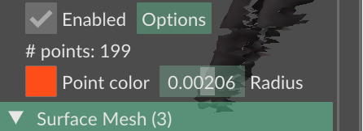
Geo endpoint
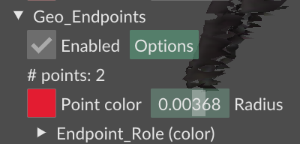

- Additional Landmark that is the intersection of the side necks and the Front and Back neck.
  - Need to extract Side Neck Left and Right to the point inline with the front neck, same for back neck
  - Use four points of the neck
  - Provide surface lengths in Z as value outputs.
  - Geodesic curve and straight length.
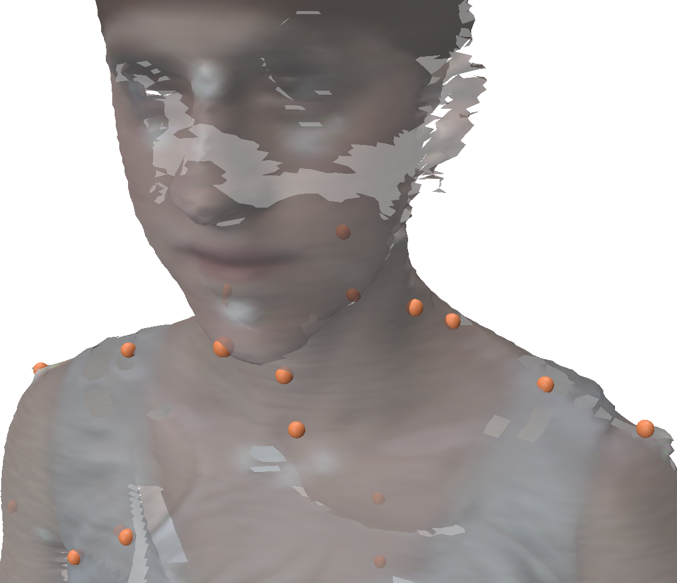
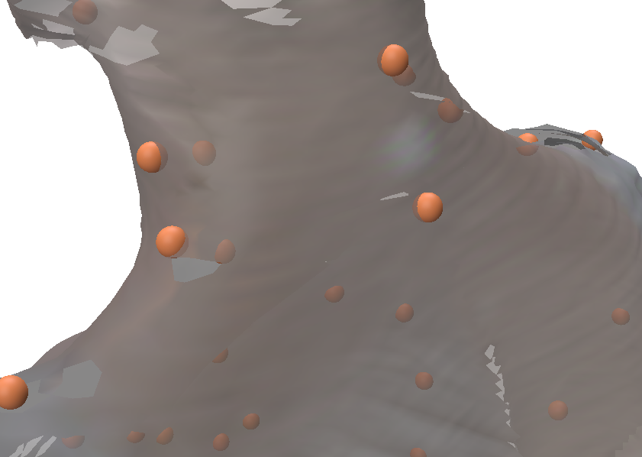
- Additional landmark 2 – extra waist landmarks
  - Create landmarks between the four existing waist landmarks
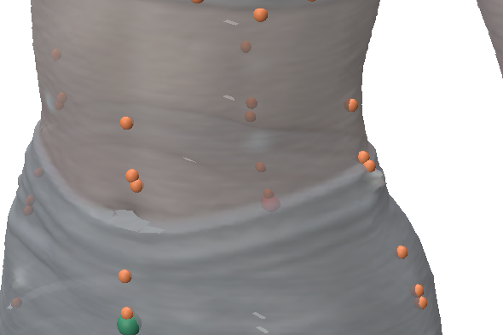
- Extra measurements of the four sections of the upper thigh
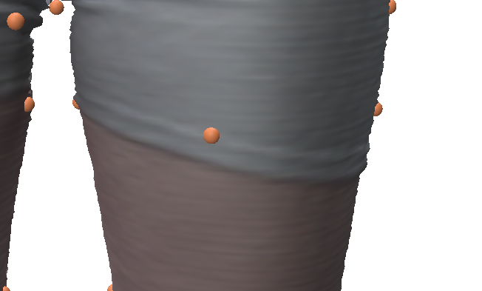
- Measurement outputs into excel, LM outputs x, y, z into excel

